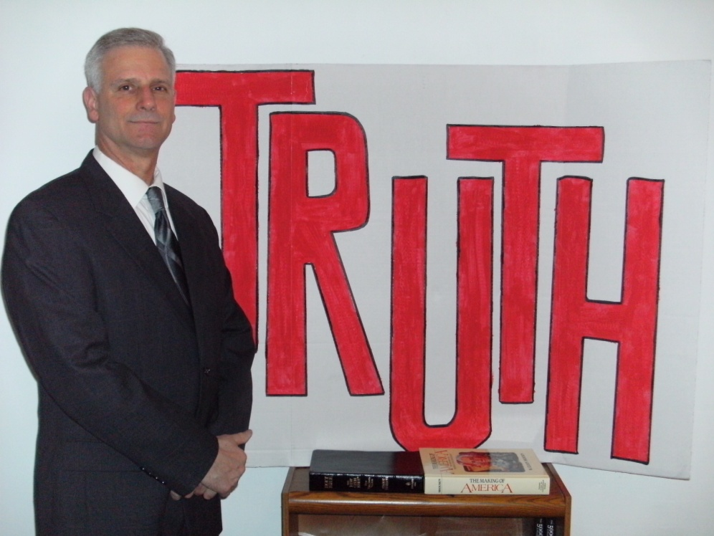
Jim Barr for State Representative
20th Legislative District

- Lifetime resident of Allegheny County
- Married to Diane since 1971
- Graduate CCAC (Allegheny Campus)
- Employed as Direct Support for mentally challenged adults
- Student of Constitutional History & Law (National Center for Constitutional Studies) www.nccs.net
As State Representative I will :
- Obey my oaths of office
- Serve the People, not politicians and bureaucrats
- Work towards eliminating property tax
- Work to nullify federal mandates
- Work to freeze compensation of legislators

Contributions accepted to “Biblical Truth Campaign”, 200 Frankfort Avenue, West View, PA 15229
Phone: 412-931-5286

